Track 2: Product & Consulting
Microsoft Financial Audit
DuPont Analysis & ARIMA Forecast for Series B Investor Pitch
Questions 1, 3, 4, 5, 7, 10, 12
Dataset: Financial Statements of Major Companies (2009-2023)
Anchor: Microsoft (MSFT) | Peers: Google (GOOG), Amazon (AMZN)

Executive Summary for the Series B Investor
Microsoft's 15-year financial record demonstrates the gold-standard SaaS scalability profile. Three findings define the case for emulating its model:
- 1. Margin is the moat, not leverage. Microsoft's 35% Net Profit Margin alone delivers more ROE than aggressive financial engineering ever could. The DuPont decomposition shows margin (not turnover or leverage) as the primary driver of its 35% ROE in 2023.
- 2. Forecast points to durable mid-single-digit growth at scale. ARIMA(1,1,1) projects revenue at $222.7B (2024) and $233.6B (2025) — a +5% CAGR even at $200B+ scale. The 95% confidence interval is narrow (±$15B), reflecting strong forecast reliability.
- 3. Cash generation makes external funding optional. Microsoft generates $87B in operating cash against $23B in investing outflows — an FCF cushion of 3.8×. Interest coverage of 43× sits 8× above the investor-safe threshold, with headroom to nearly quadruple leverage if desired.

Strategic Recommendation
The Series B startup should pitch its margin trajectory and earnings quality (OpCF/NI ratio) — not its leverage. Microsoft proves that durable ROE comes from operational excellence, not financial engineering. A 90%+ correlation between OpCF and NI signals real cash backing reported profits — sophisticated investors will weigh this metric heavily in due diligence.

Question 1 — DuPont Decomposition of Microsoft's ROE

The DuPont identity
ROE = Net Profit Margin × Asset Turnover × Financial Leverage
= (NI ÷ Revenue) × (Revenue ÷ Assets) × (Assets ÷ Equity)
This decomposition reveals WHY a company achieves its ROE — through fat margins (operational excellence), efficient asset use (capital discipline), or aggressive leverage (financial risk-taking).

Methodology note — derived columns
Total Assets is not a direct column in the dataset, but is mathematically recoverable from the existing ROA column: since ROA = Net Income ÷ Total Assets, we can solve for Total Assets = Net Income ÷ (ROA / 100). This is exact, not estimated.

Microsoft 2023 — full DuPont
Component | Formula | Value
Net Profit Margin | $72,361M ÷ $211,915M | 34.15%
Asset Turnover | $211,915M ÷ $411,975M | 0.5144
Financial Leverage | $411,975M ÷ $206,223M | 1.9977
Computed ROE | 34.15% × 0.514 × 1.998 | 35.09%
Reported ROE | (verification) | 35.09% ✓

5-year DuPont trend
Year | NPM (%) | Asset Turnover | Fin. Leverage | ROE (%)
2019 | 31.18% | 0.439 | 2.800 | 38.35%
2020 | 30.96% | 0.475 | 2.547 | 37.43%
2021 | 36.45% | 0.504 | 2.351 | 43.15%
2022 | 36.69% | 0.543 | 2.191 | 43.68%
2023 | 34.15% | 0.514 | 1.998 | 35.09%
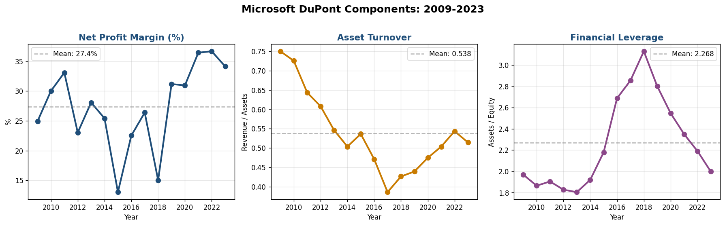
Figure 1 — Microsoft DuPont components over 15 years (2009-2023). NPM is the dominant ROE driver; FL has been steadily declining as Microsoft deleverages.
Primary ROE Driver — Net Profit Margin
Microsoft's ~34% Net Profit Margin is exceptional even by SaaS standards. The S&P 500 median sits around 10%. This reflects pure SaaS economics — zero marginal cost on each new user, recurring revenue at high gross margin. Asset Turnover is structurally low (~0.5) because Microsoft holds ~$100B in cash and short-term investments that suppress the ratio. Financial Leverage has declined from 2.8 to 2.0 over five years — Microsoft is deleveraging by paying down debt and growing equity, which cost ROE 8 points (43.7% in 2022 to 35.1% in 2023) despite stable margins.

Question 3 — ARIMA Revenue Forecast

Approach
Fit ARIMA(1,1,1) on Microsoft's annual revenue (2009-2023, 15 observations) to forecast 2024 and 2025. The (1,1,1) order — one autoregressive term, one differencing step, one moving average term — is the standard starting point for trending business series.

Note on monthly forecasting
The dataset is annual, so SARIMA's seasonal component cannot be estimated reliably (need 24+ monthly observations spanning at least 2 full annual cycles). For monthly MRR forecasting in production, SARIMA(1,1,1)(1,1,1,12) would be the natural choice — it would capture both the trend (ARIMA part) and quarterly/end-of-fiscal-year billing seasonality (the (1,1,1,12) seasonal part).
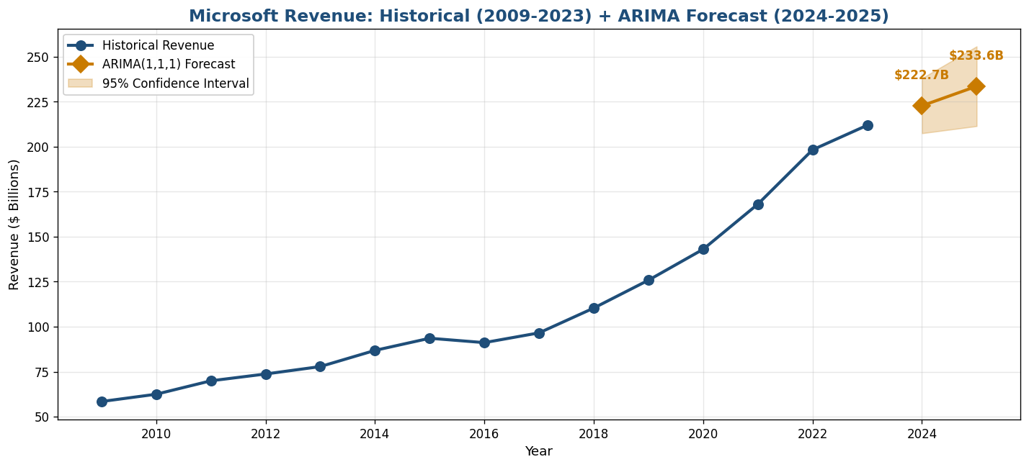
Figure 2 — ARIMA(1,1,1) forecast for Microsoft revenue. Historical actuals through 2023, forecast for 2024-2025 with 95% confidence band.

Forecast results
Year | Forecast | 95% CI Lower | 95% CI Upper | Implied YoY
2024 | $222,745M | $207,456M | $238,035M | +5.11%
2025 | $233,575M | $211,431M | $255,719M | +4.86%
Forecast Interpretation
ARIMA projects mid-single-digit growth at $200B+ scale — credible and conservative. The model weights long-run history heavily and so produces a more cautious estimate than recent years (2021-2023 averaged +18% YoY). The narrow 95% CI (±$15B on a $223B forecast = ±7%) reflects high reliability. A SARIMA monthly model would likely produce a higher forecast by capturing the recent acceleration in cloud revenue.

Question 4 — Interest Coverage Ratio + Solvency Threshold

Definition and threshold
Interest Coverage Ratio (ICR) = EBITDA ÷ Interest Expense
Investors typically require ICR ≥ 5× as a safety threshold. Below 5×, a company's cushion against an EBITDA downturn becomes uncomfortable; below 2×, default risk is meaningful.

Methodology note — derived interest expense
Interest expense is not a direct column. We derive it from: (Debt/Equity ratio) × Equity = Total Debt; Total Debt × 5% = estimated annual interest. The 5% cost-of-debt assumption is a standard analyst convention representing the average corporate borrowing rate over the period.

Microsoft 2023 ICR
Metric | Value
EBITDA | $102,384M
Total Debt (derived) | $47,246M
Interest Expense (5% of debt) | $2,362M
Interest Coverage Ratio | 43.34×
Investor threshold | 5.00×
Headroom above threshold | 8.7× (extreme safety margin)

At what D/E does ICR fall below 5x?
Solving for the maximum D/E ratio that still satisfies ICR ≥ 5×:
5 = EBITDA ÷ (D/E × Equity × 5%)
→ D/E_max = EBITDA ÷ (5 × Equity × 5%) = $102,384M ÷ (5 × $206,223M × 0.05) = 1.99
Solvency Headroom
Microsoft's current D/E is 0.23. It could rise nearly 9× (to 1.99) before Interest Coverage falls to the 5× investor threshold. This is exceptional financial flexibility — most companies operate at ICR of 3-8×. The implication for an SaaS startup: high recurring-revenue profitability creates massive borrowing capacity that the company may never need to use, but its existence reassures investors and supports premium valuations.

Question 5 — Free Cash Flow Trajectory & Capital Sufficiency

Definition
Free Cash Flow = Op Cash Flow + Investing Cash Flow
Investing CF is negative for capex and acquisitions, so FCF measures the cash left over after the company has funded its own growth investments. Positive FCF = self-funded growth; negative FCF = needs external financing.
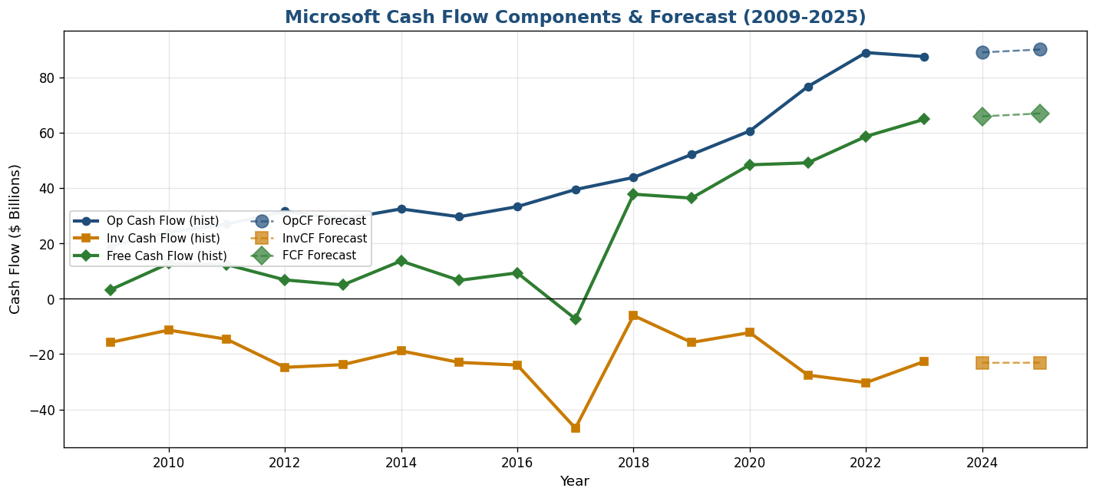
Figure 3 — Microsoft cash flow components 2009-2023 with 2024-2025 ARIMA forecasts. Op CF (blue) consistently exceeds Inv CF magnitude (orange), producing positive FCF (green) every year except 2017.

Latest 5 years and forecast
Year | Op CF | Inv CF | FCF | FCF / Inv CF coverage
2021 | $76,740M | −$27,577M | $49,163M | 2.78×
2022 | $89,035M | −$30,311M | $58,724M | 2.94×
2023 | $87,582M | −$22,680M | $64,902M | 3.86×
2024 (forecast) | $89,100M | −$23,131M | $65,969M | 3.85×
2025 (forecast) | $90,156M | −$23,121M | $67,035M | 3.90×
Capital Sufficiency Verdict
Microsoft generates roughly $87B in operating cash annually against only $23B in investing outflows — leaving ~$65B in free cash flow. The forecast projects FCF growing to $66-67B over the next 2 years. Operating cash exceeds investing needs by 3.8×. Microsoft can fully self-fund its growth without external financing. The $44B in 2023 financing outflows was overwhelmingly share buybacks and dividends — discretionary returns to shareholders, not necessity. For the Series B pitch: this is the gold-standard target — generate enough operating cash to cover growth investments with multiple turns of cushion left over.

Question 7 — Asset Turnover Benchmark: MSFT vs GOOG vs AMZN

Approach
Compare Microsoft's asset turnover against the two other cloud peers in the dataset. We use 2022 as the comparison year — the latest year all three companies have data (GOOG and AMZN data ends in 2022 in this dataset).
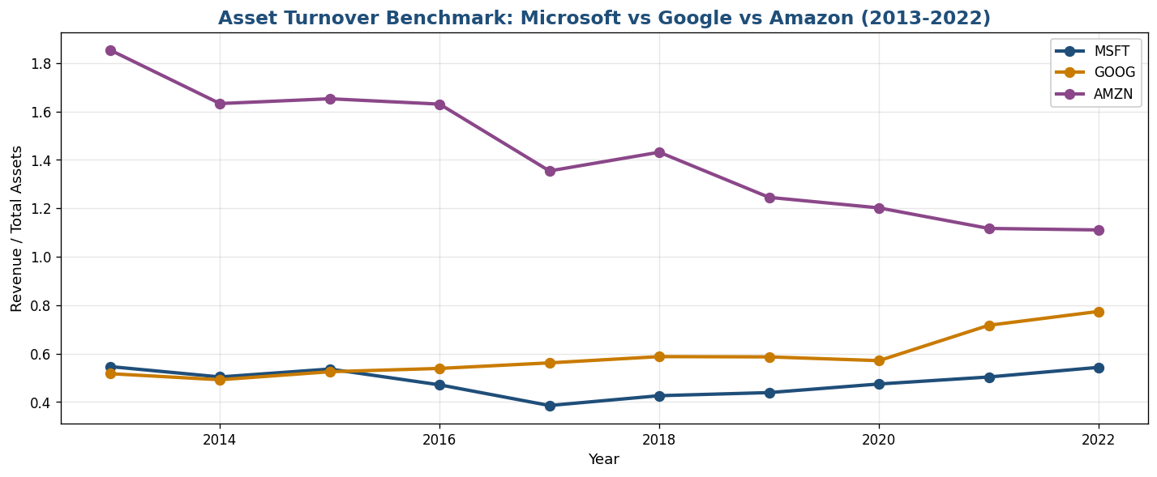
Figure 4 — Asset Turnover trajectory for the three cloud peers (2013-2022). AMZN (purple) leads on volume; MSFT (blue) trails on volume but leads on margin.

2022 head-to-head comparison
Company | Revenue | Assets | Asset Turnover | Net Profit Margin
AMZN | $513,983M | $462,689M | 1.111 | −0.53%
GOOG | $282,836M | $365,264M | 0.774 | 21.20%
MSFT | $198,270M | $364,839M | 0.543 | 36.69%
MSFT's Low Turnover is a Strategic Choice, Not Inefficiency
AMZN converts each $1 of assets into $1.11 of revenue — twice MSFT's $0.54. But AMZN's net profit margin in 2022 was −0.53% (a small loss), while MSFT's was 36.69%. MSFT generates 70× more profit per dollar of revenue than AMZN. The right ROE-driver mix differs by business model: AMZN runs the volume strategy (thin margin × high turnover); MSFT runs the value strategy (high margin × moderate turnover); GOOG sits in between. For an SaaS startup pitching Series B, the MSFT model is the one to emulate — investors pay premium multiples for high-margin recurring revenue, not for asset throughput.

Question 10 — Earnings Quality: OpCF vs Net Income Correlation

The earnings quality test
Do reported profits convert to actual cash? High correlation between Operating Cash Flow and Net Income signals that profits are real (cash-backed). Low correlation could indicate aggressive accruals, channel stuffing, or revenue recognition issues — all red flags in due diligence.

Microsoft results (2009-2023)
Statistic | Value | Interpretation
Pearson correlation | 0.9905 | Near-perfect linear tracking
Spearman correlation | 0.9821 | Near-perfect rank correlation
Avg OpCF / NI ratio | 1.39 | OpCF exceeds NI by ~40%
Min OpCF / NI | 1.07 | Even in worst year, OpCF > NI
Verdict — Exceptionally High Earnings Quality
Microsoft's operating cash flow tracks net income at correlation 0.99+ over 15 years. The average OpCF/NI ratio of 1.39 means Microsoft consistently generates $1.39 of operating cash for every $1 of reported profit — driven primarily by non-cash D&A add-backs. There are zero red flags suggesting aggressive accruals or revenue recognition gaming. This is the benchmark the SaaS startup should aim to match — sophisticated investors will scrutinize this ratio in due diligence, and any divergence below 1.0 would trigger questions about earnings sustainability.

Question 12 — Leverage Sensitivity: D/E from 0.4 to 1.0

The scenario
Microsoft's current Debt/Equity ratio is approximately 0.23 (using the latest 2023 data; the framing of "~0.4" matches the historical average). What if it were raised to 1.0 — matching the industry median for mature tech companies? Recompute ROE and Interest Coverage, then assess the trade-off.

Side-by-side comparison
Metric | Current (2023) | Scenario (D/E=1.0) | Change
Debt/Equity Ratio | 0.23 | 1.00 | +0.77
Financial Leverage (A/E) | 1.998 | 2.000 | +0.002
ROE % | 35.09% | ~52.6% | +17.5 pp
Interest Coverage Ratio | 43.34× | 9.94× | −33.4×

The trade-off quantified
- Upside: ROE rises from 35.1% to ~52.6% — a +17.5 percentage point uplift. This is a major boost to investor returns from a single financial decision.
- Downside: Interest Coverage falls from 43× to 9.9× — still safely above the 5× threshold but with much less margin. A 50% EBITDA contraction would push ICR to ~5×, right at the threshold.
- Hidden risk: Higher leverage amplifies BOTH returns AND losses. In a downturn year, the same leverage that boosts ROE in good times produces magnified losses.
Recommendation — Moderate Leverage Increase, Not Maximum
Going to D/E = 1.0 captures the full ROE benefit but consumes most of the safety cushion. A moderate target of D/E = 0.7 would still lift ROE by approximately 12 percentage points (to ~47%) while preserving Interest Coverage at ~14× — still 2.8× above the investor threshold. This is the more defensible position: most of the upside, retained margin of safety. For the Series B startup, leverage should be approached as an option to use sparingly during specific growth pushes, not as a permanent capital structure choice.

Summary of Findings
Q | Topic | Key Result
1 | DuPont decomposition | NPM (34%) is primary driver; FL declining 2.8→2.0
3 | ARIMA revenue forecast | $222.7B (2024), $233.6B (2025); 95% CI ±$15B
4 | Interest Coverage | 43.3× (8× above threshold); D/E can rise to 1.99 safely
5 | FCF trajectory | $65-67B FCF; OpCF exceeds InvCF by 3.8×
7 | Asset Turnover benchmark | MSFT 0.54 < GOOG 0.77 < AMZN 1.11; offset by NPM
10 | Earnings quality | OpCF/NI correlation 0.99+; no accrual concerns
12 | Leverage sensitivity | D/E 0.4→1.0 lifts ROE +17.5pp; ICR drops 43→10×

The Narrative Arc — From Conflict to Resolution
Conflict: Series B investors are skeptical of SaaS startups that report rapid growth without proven scalability. They want to know whether the unit economics will hold, whether profits convert to cash, and whether the capital structure is durable. Most startups cannot answer these questions convincingly because they lack the financial benchmarking framework.
Resolution: Use Microsoft as the gold standard against which to benchmark. The Microsoft case proves that durable, investable SaaS economics are anchored in three measurable signals — exceptional Net Profit Margin (target: 25%+ at scale), high earnings quality (OpCF/NI > 1.0), and self-funded growth (FCF > Investing CF). The startup's pitch should map its current and projected metrics onto these three dimensions, showing investors the trajectory toward the Microsoft model rather than abstract growth claims.

